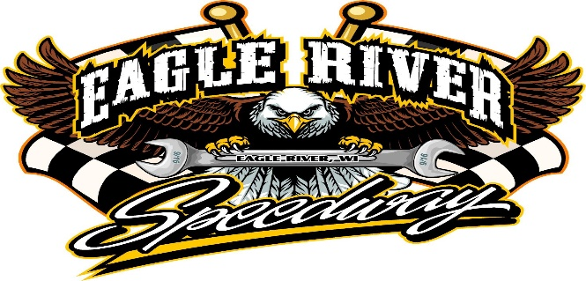
2021 Schedule
- Friday, May 28 Test and Tune/ Banquet/ 2020 Awards Ceremony Test and tune
- Sunday, May 30 Lid Lifter- Start with a BLAST
Our regular 6 classes plus Pure Stocks and Chequamegon Renegades Wingless Sprint Series Exhibition!
- June 8th Schools Out!
- June 15 Bike Night! Drawings for lots and lots of bikes for the kiddos! Stock Car Special!
- June 18 Test and Tune
- June 22 First night of three! TRIPLE CROWN B- MOD SPECIAL $1000 to win! (G- 60 tires only!)
- June 29 Fireworks Spectacular! Our six regular classes plus Pure Stocks!
- July 6 Street Stock Special, Fireworks, Chequamegon Renegades Wingless Sprint Series Exhibition!
- July 9 Test and Tune
- July 13 Mid-Season Madness- Increased pay-out all classes!
- July 20 Christmas in July- Door prizes for all ages. Autograph night! Our six classes plus Pure Stocks!
- July 23 Test and Tune
- July 27 Second night of the B-Mod Triple Crown! $1000 to win!! (G-60 tires only)
- August 3 ERS Late Model Special! Chequamegon Renegades Wingless Sprint Series Exhibition!
- August 10 Back to school- backpack giveaways. Our 6 classes plus Pure Stocks!
- August 13 Test and Tune
- August 17 Third and final night of the B-Mod Triple Crown! $1000 to win!! (G-60s only)
- August 24 Season Championship Night! Autograph Night! Free checker flags for the kids!
Chequamegon Renegades Wingless Sprint Series Exhibition
- September 3rd Test and Tune
- September 4th TWO NIGHT SPECIAL! Sept.4th at Eagle River Speedway, Sept. 5th at TNT Speedway
MUST RUN BOTH NIGHTS TO BE ELIBIBLE FOR THE TWO NIGHT SPECIAL POINT FUND!
Micro and Junior Sprint Special!

More info coming soon!

Triple Crown B-Mod Special participants must participate ALL THREE NIGHTS to be eligible for the points fund. $1500 MINIMUM points fund to winner!!

****Schedule subject to change.

